**WEB SERVICES ASSIGNMENT**

**( AWS HANDS ON )**

**Roll No. 6911**

**Pooja Deshpande**

**Amazon DynamoDB**

**Overview**

DynamoDB allows users to create databases capable of storing and retrieving any amount of data, and serving any amount of traffic. It automatically distributes data and traffic over servers to dynamically manage each customer's requests, and also maintains fast performance.

DynamoDB uses a NoSQL model, which means it uses a non-relational system

**Hands-On Practical Includes:**

* Creation of table
* Adding data to table
* Modification of data in table
* Querying the table
* Deletion of table

***TASK 1 : Table Creation***

We first click on “**Services**” tab in left top corner

A drop down menu with all services appears ,

Under category storage we select “**DynamoDB**”

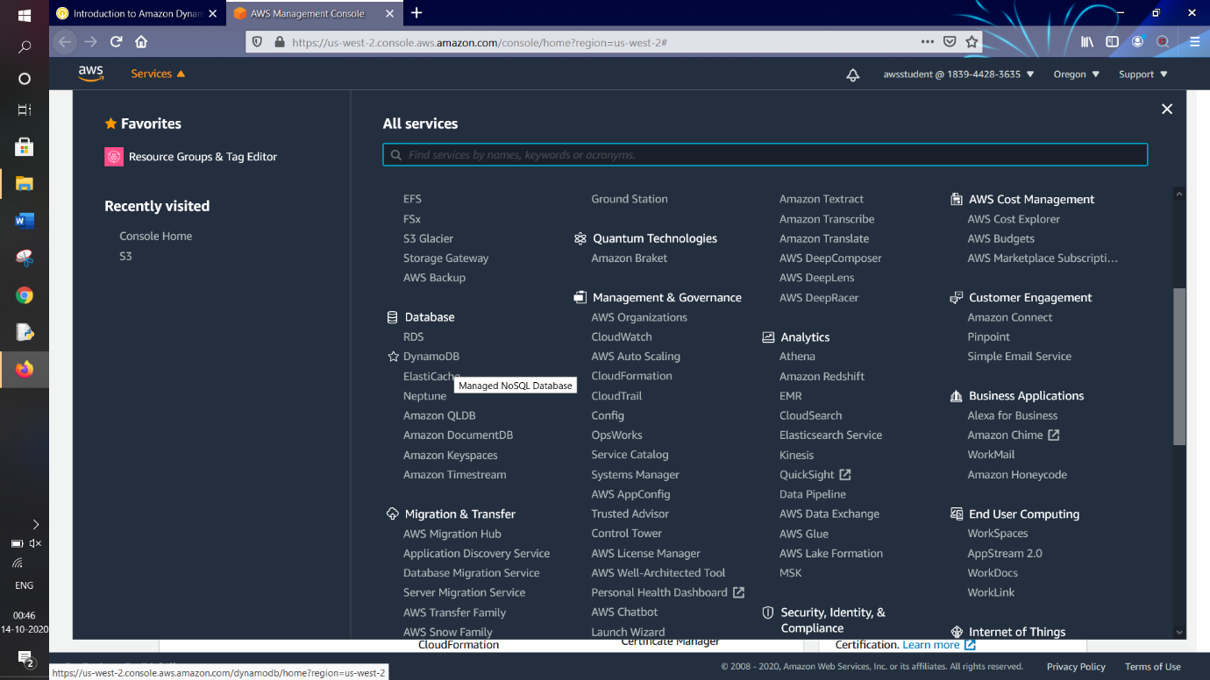

DynamoDB : AWS console appears

Click on “**Create table**” button 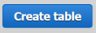

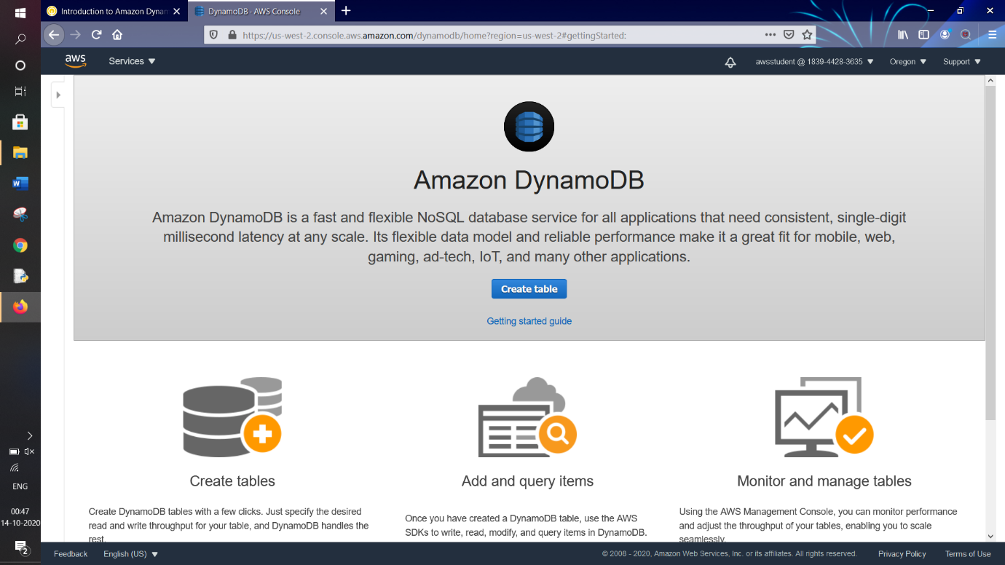

The below page appears with all table creation options

Put Table name* = **Music**

Put Primary Key* = **Artist**

Keep the datatype of the attribute as **String**

Select the “**Add Key**” option

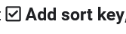

And in the newly appeared field enter the value “**Song**” . Keep the data type of ‘Song’ as **String**

This table will use default settings for indexes and provisioned capacity

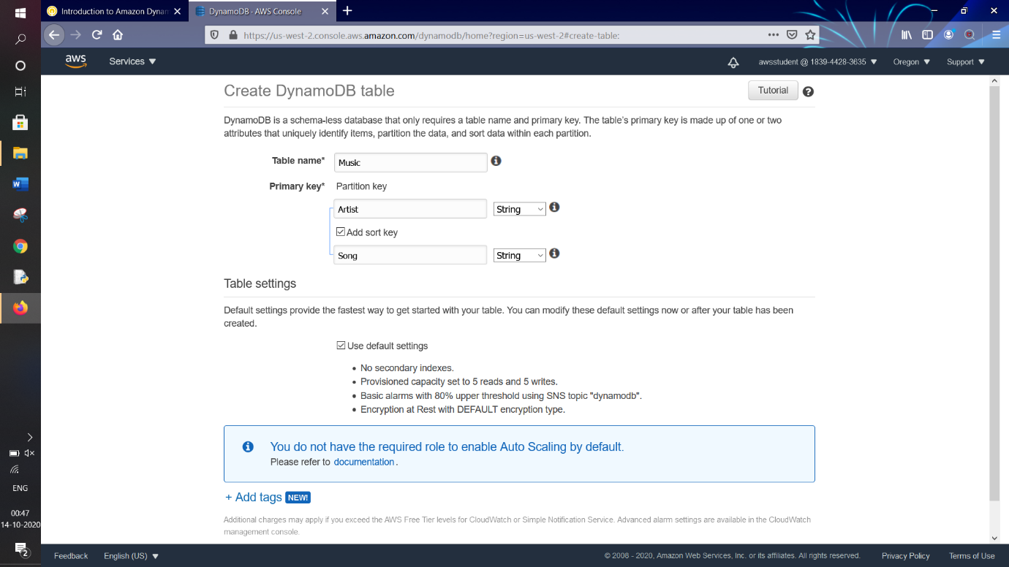

Click on “**Create**” button



A table will be created in less than a minute

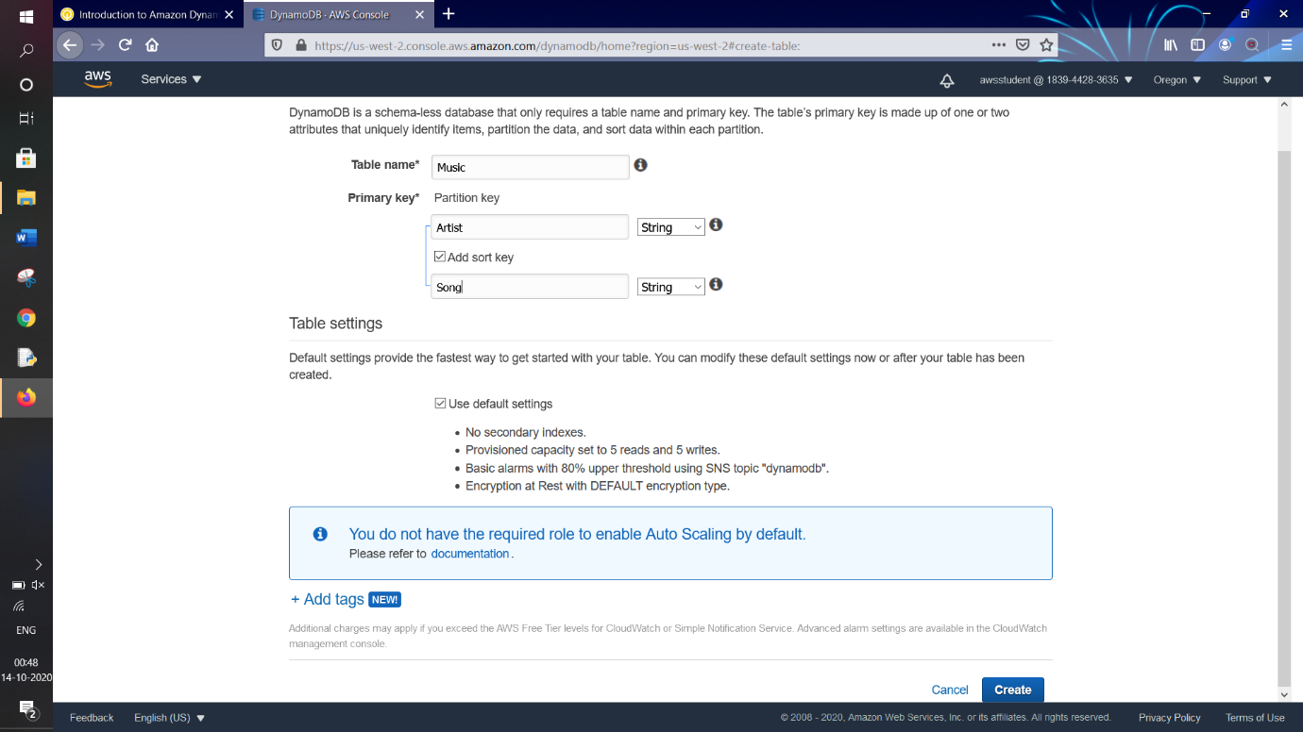

Below Image shows that a table “**Music**” has been created and we get an overview of the table details and properties with all setting that are set for this table

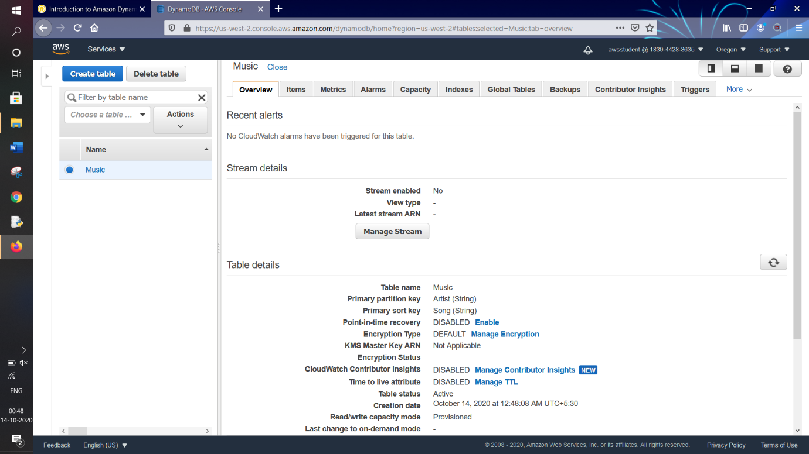

***TASK 2 : Add Data***

Click on the “**Items**” tab



Then, click on “**Create Item**”

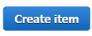

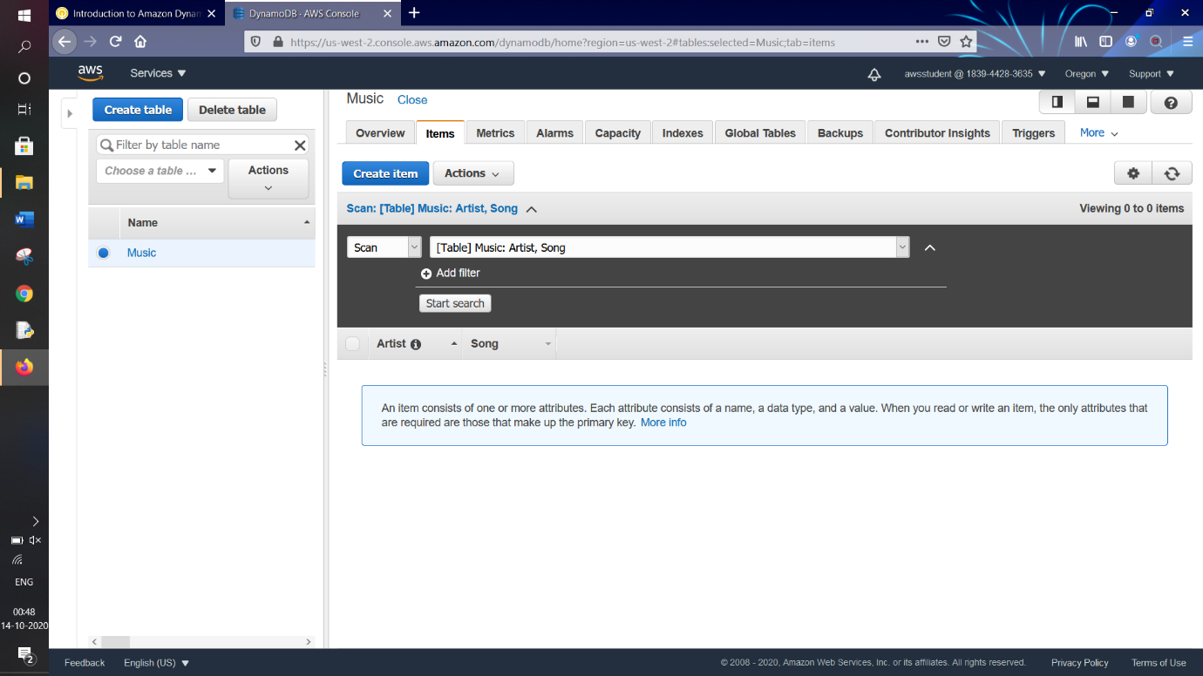

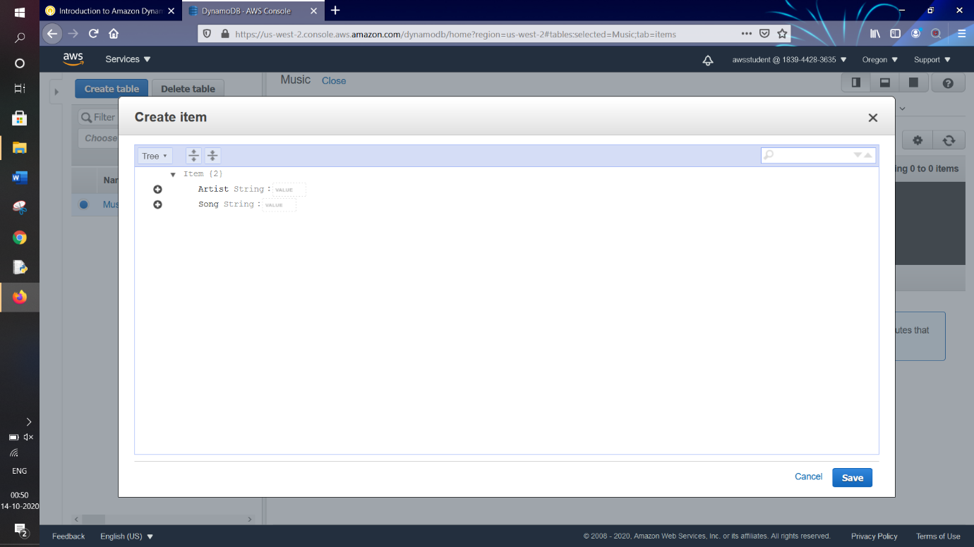

For “**Artist**” String : Type “**Ed Sheeran**”

For “**Song**” String : Type “**Perfect**”

These were our pre-defined attributes, but in next step we will add extra attributes

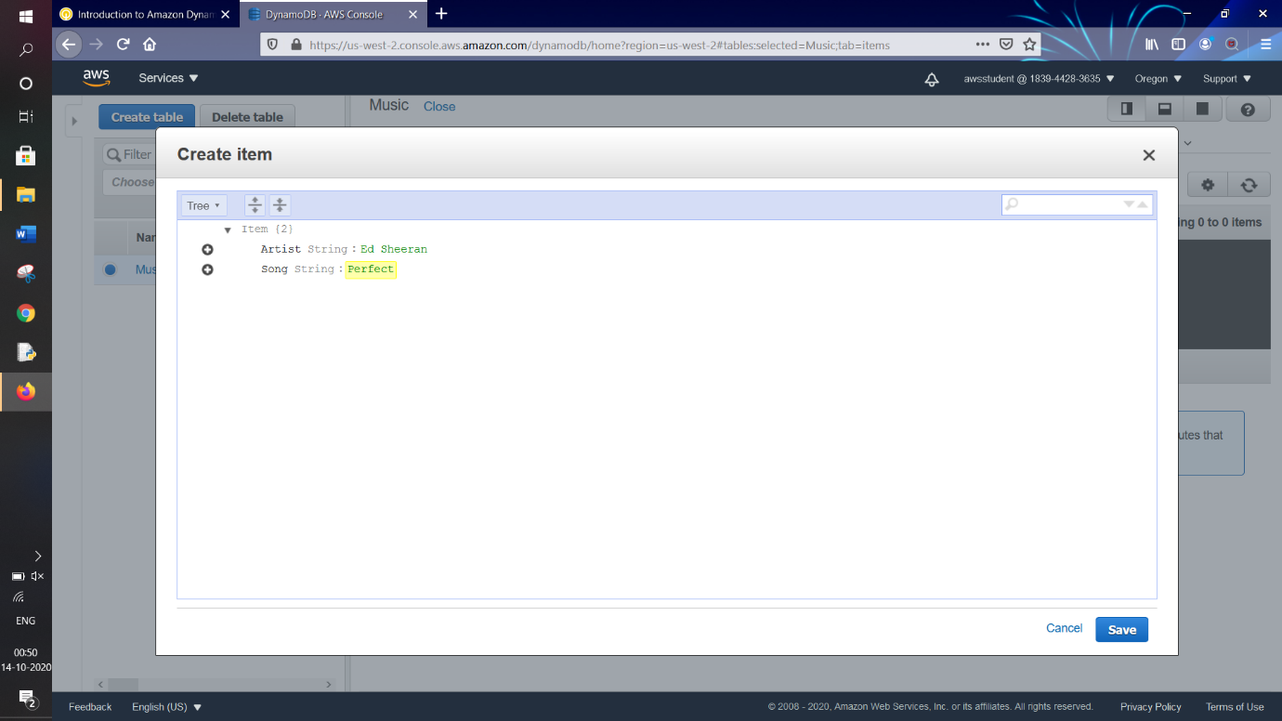

For extra attributes,

To create an additional attribute, click on  sign button to left of “Song”,

Then click on “**Append**”

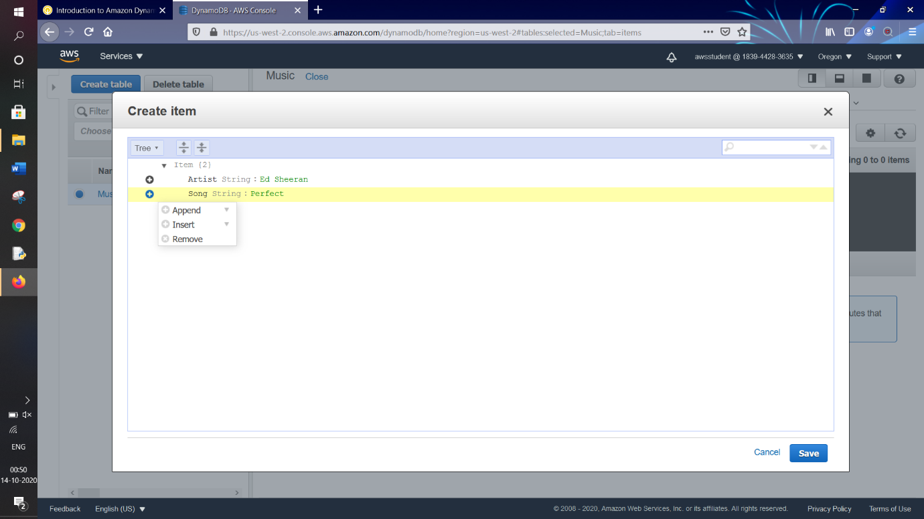

Then select the “**String**” datatype

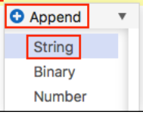

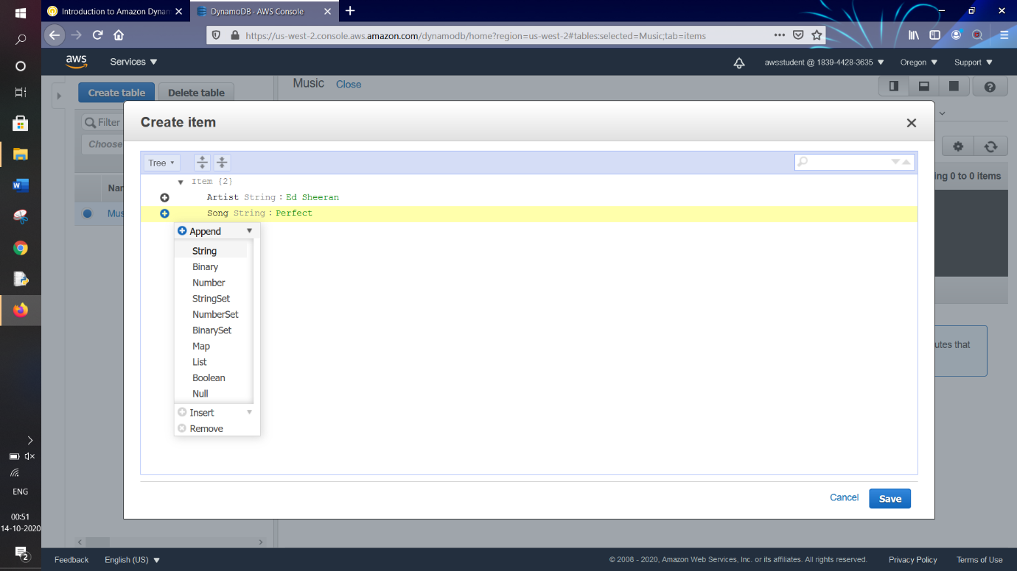

A new attribute row will be added

In **Field:** type “**Album**”

In **Value:** type “**The other side**”

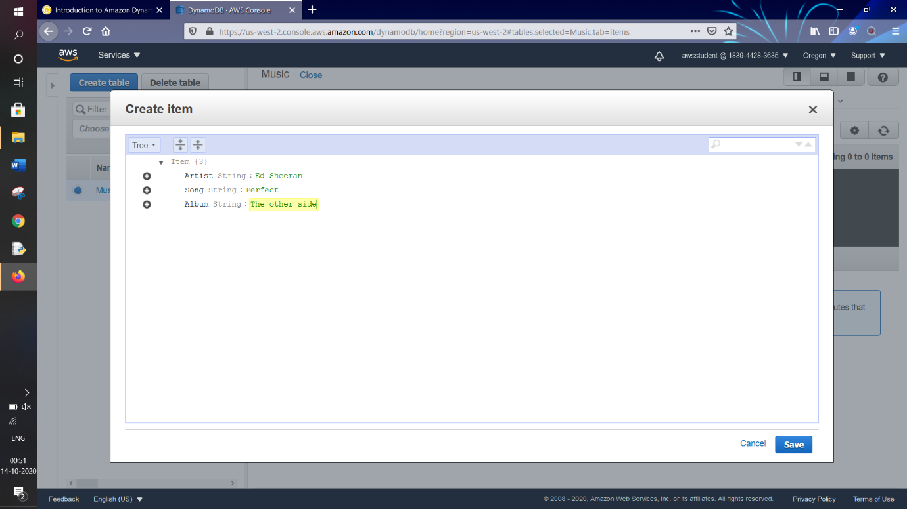

We want to add an additional attribute “**Year**”

Add another attribute by clicking  button on left side “**Album**”, then click on “**Append**”

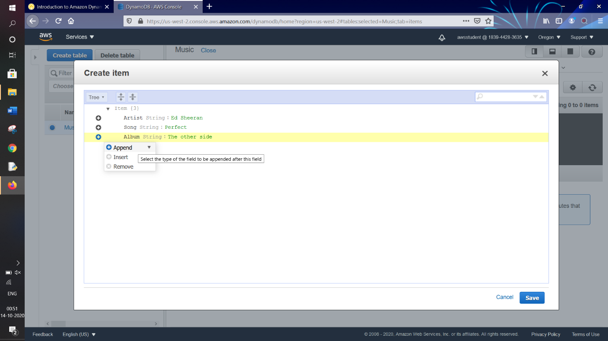

This time as “**Year**” which we will add is a numerical value hence,

We select “**Number**” from the dropdown

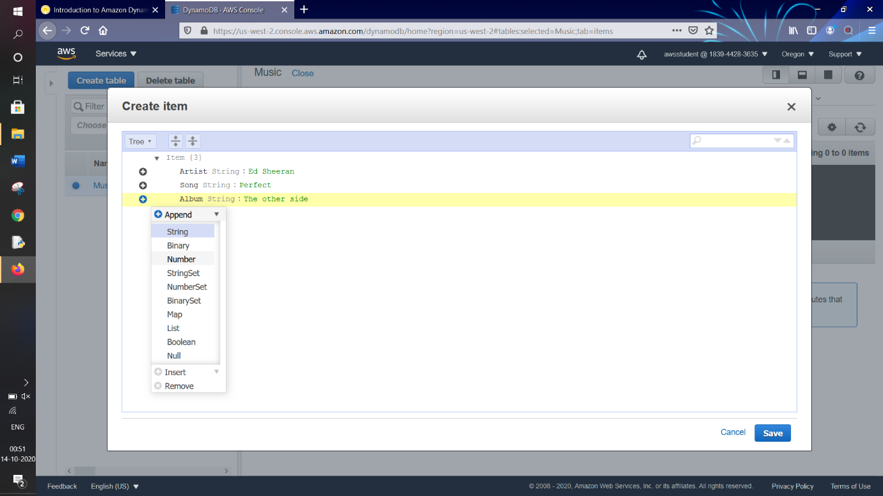

In **Field:** type “**Year**”

In **Value:** type “2017”

After we click on “**Save**” button



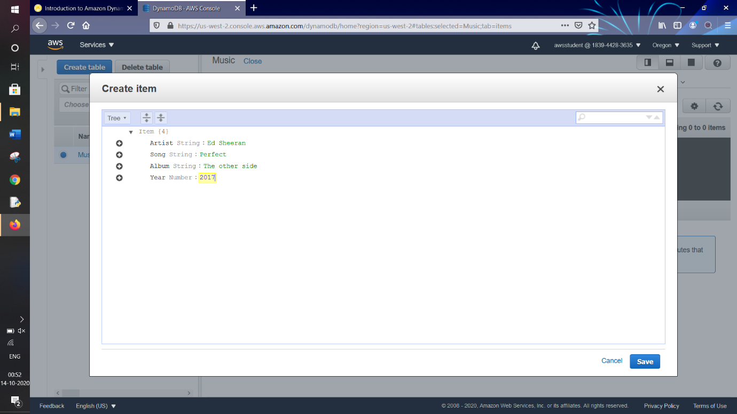

We see that a row has been added to our table with the pre-defined as well as newly defined attributes for that record

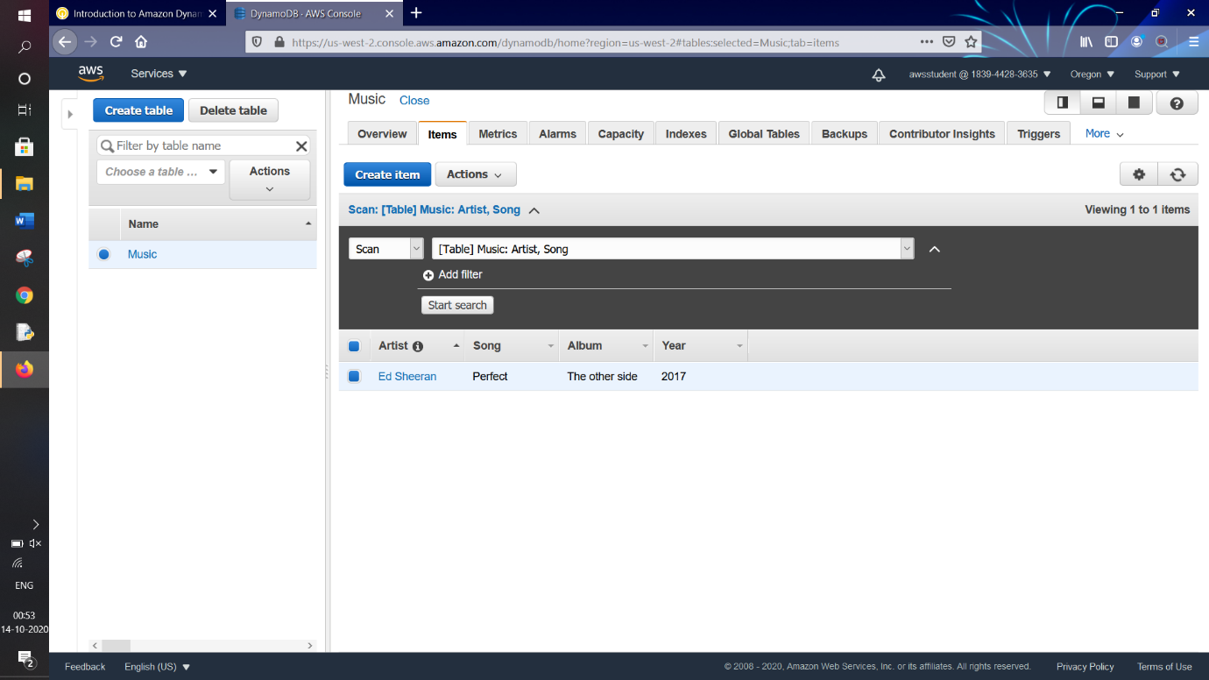

Now we will add two more records in table,

Then again, click on “**Create Item**”



This time it will only show the pre-defined attributes not the newly-created attributes for the previous record

In “**Artist**” String : type “**Linkin Park**”

In “**Song**” String : type “**Battle Symphony**”

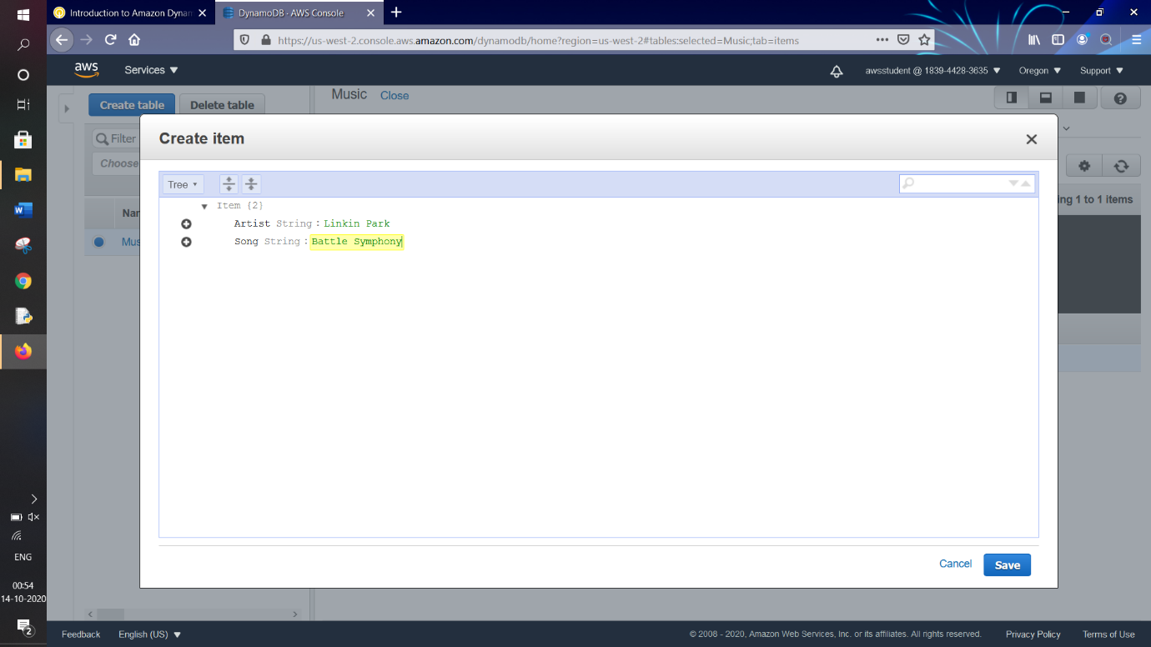

For this record we add two different attributes

Add another attribute by clicking  button on left side “**Song**”, then click on “**Append**”

We select “**String**” from dropdown

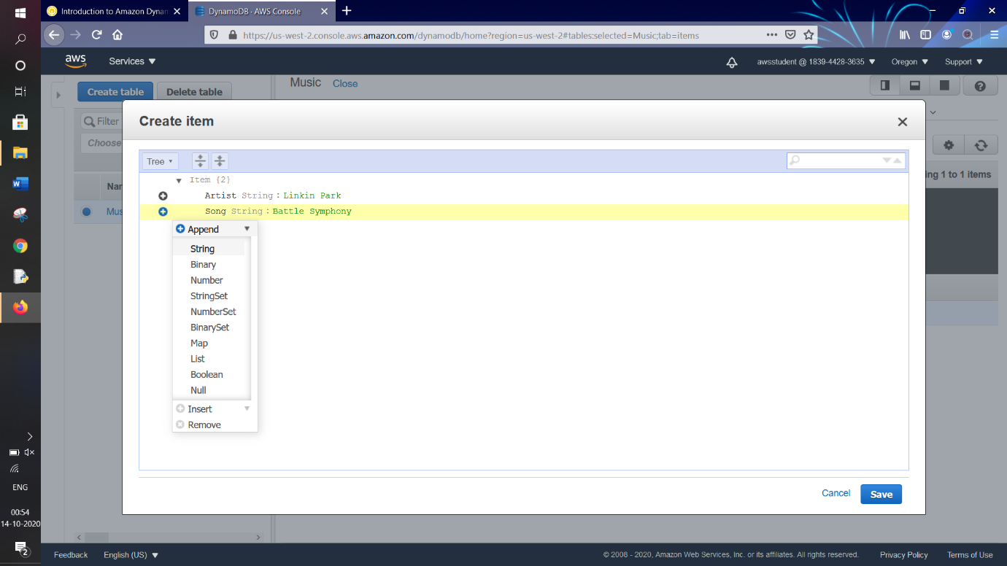

In **Field:** type “**Album**”

In **Value:** type “**Ugly Wars**”

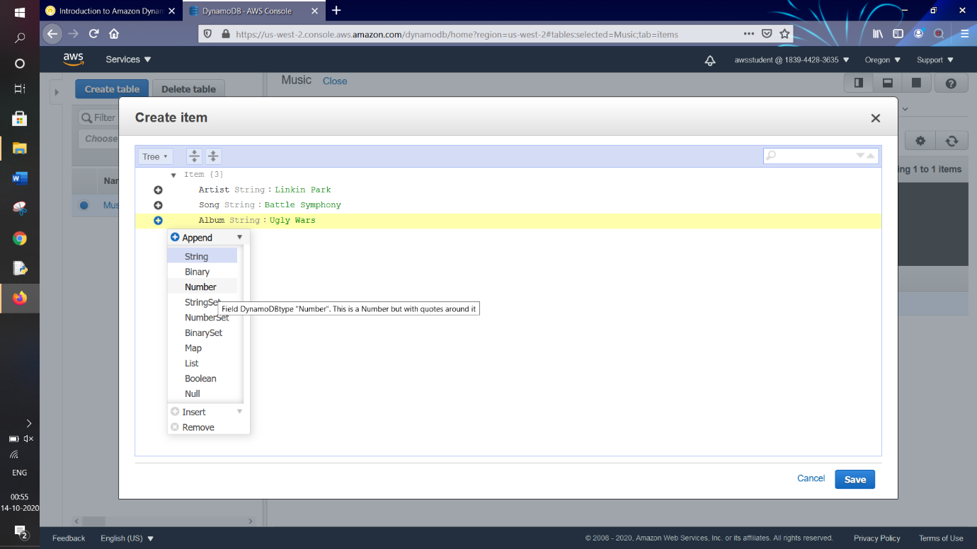

Similarly we add another attribute “**Year**” with value “**2012**”

After we click on “**Save**” button



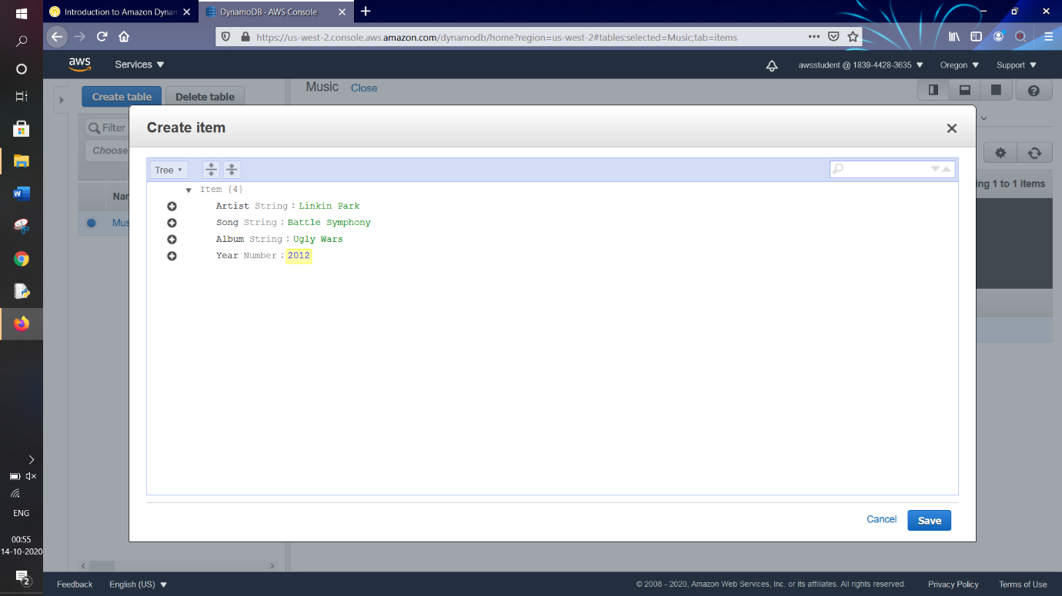

We see that two records are existing in our table

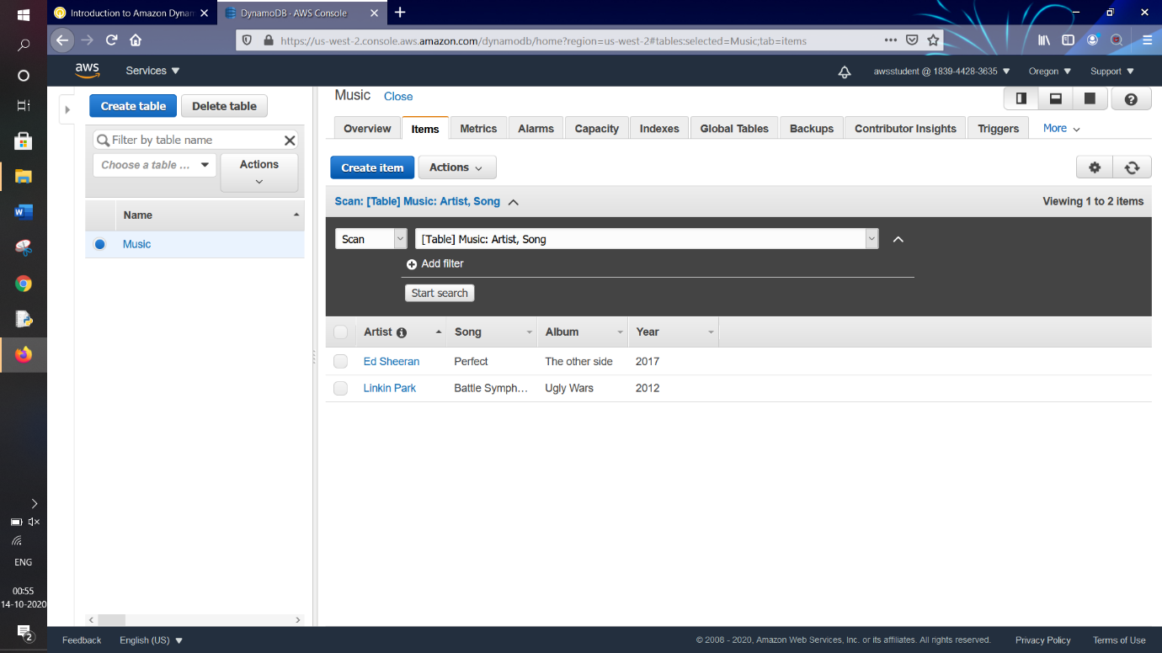

Then again for third record, click on “**Create item**”



This time also it will only show the pre-defined attributes not the newly-created attributes for the previous record

In “**Artist**” String : type “**Sia**”

In “**Song**” String : type “**Cheap Thrills**”

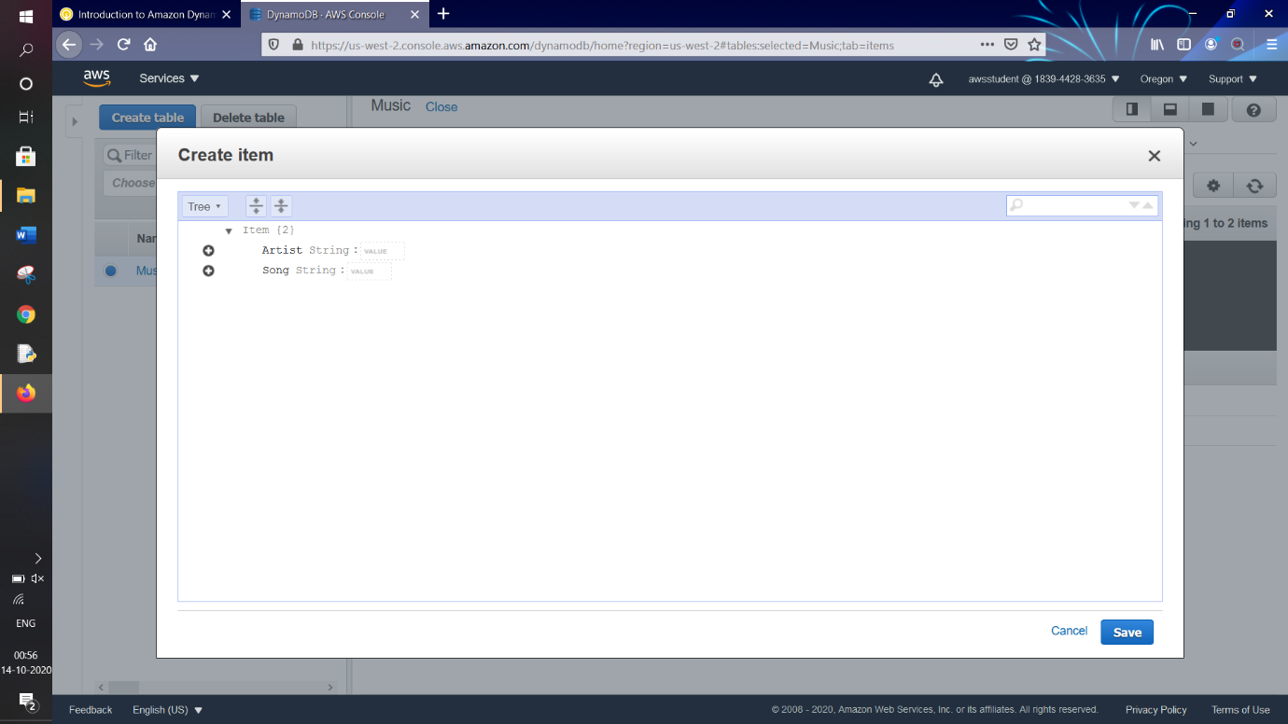

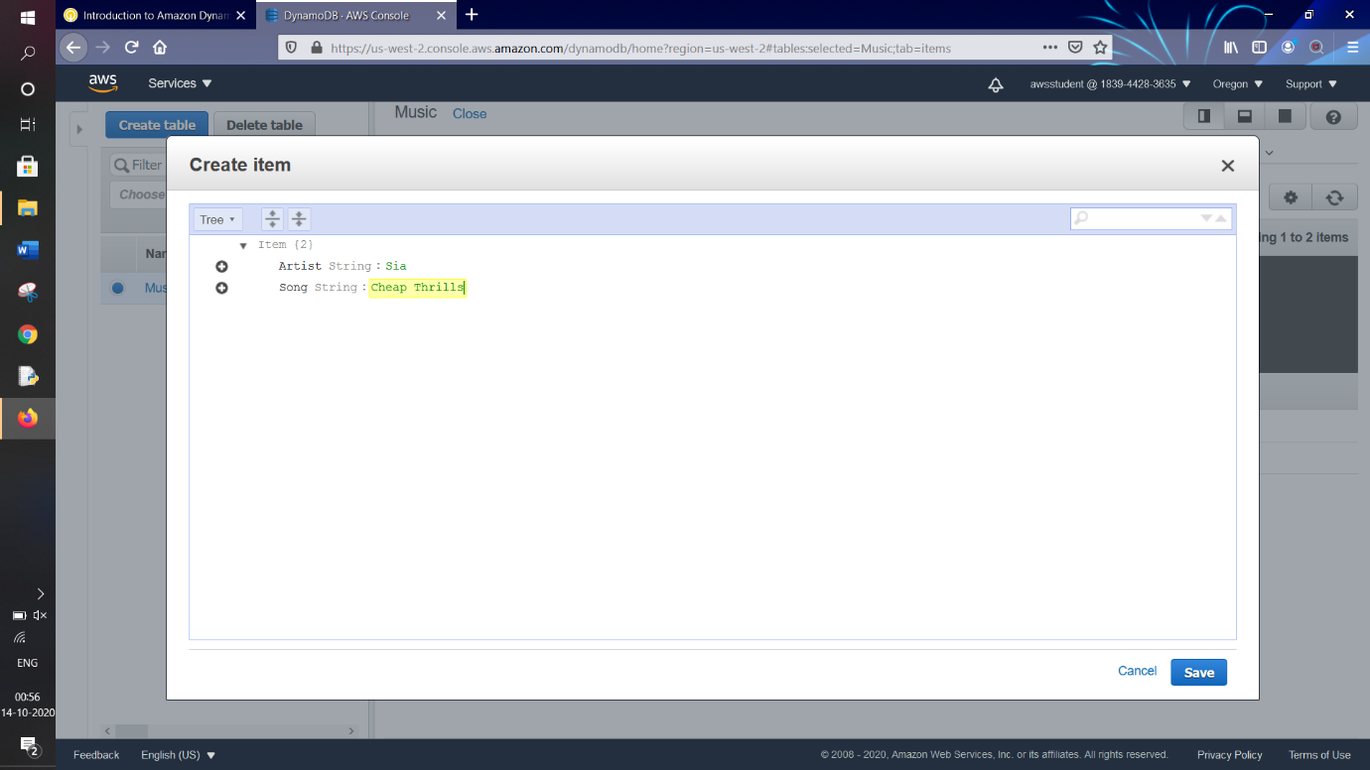

For this record we add additional attributes,

Add another attribute by clicking  button on left side “**Song**”, then click on “**Append**”

We select “**String**” from dropdown

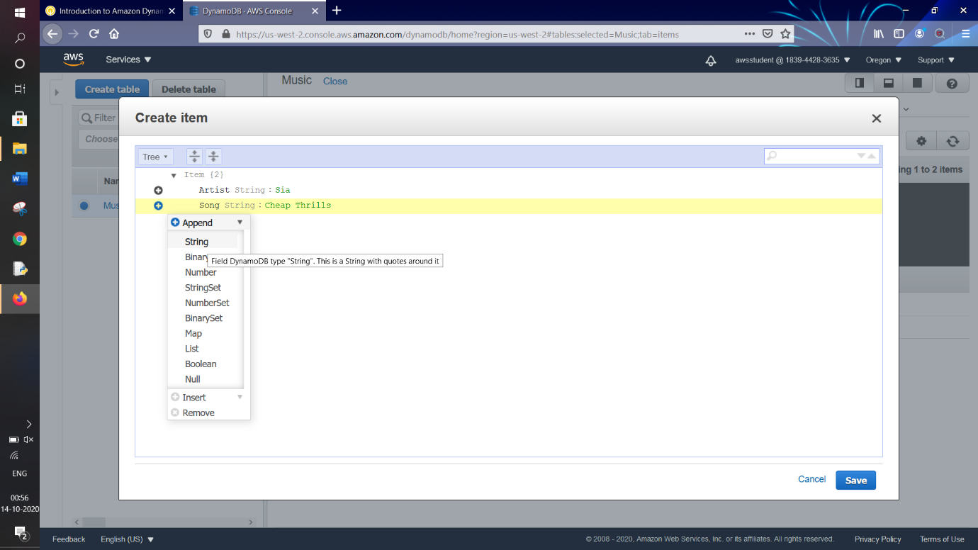

In **Field:** type “**Album**”

In **Value:** type “**Party**”

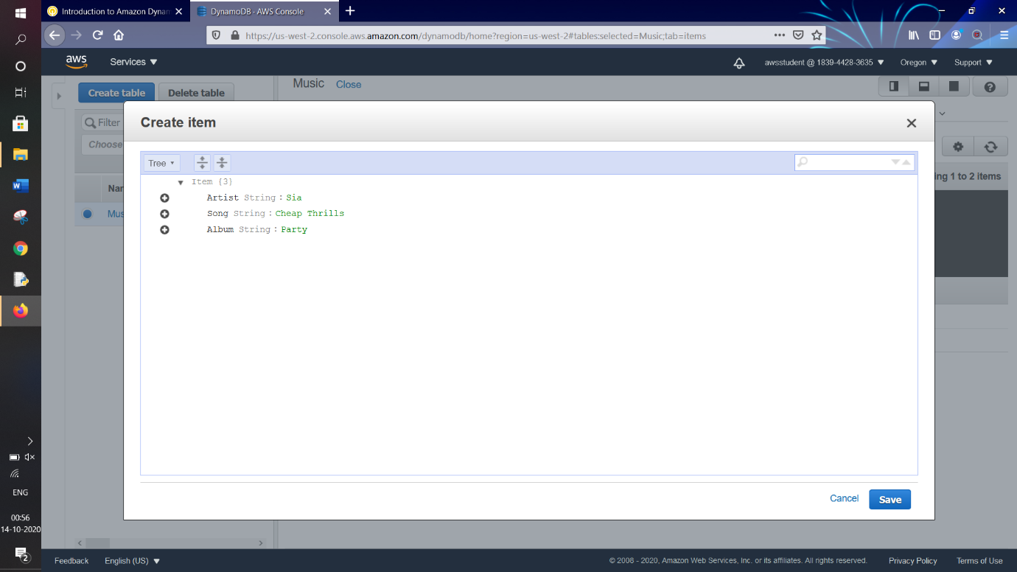

Similarly we add another attribute “**Year**” with value “**2010**”

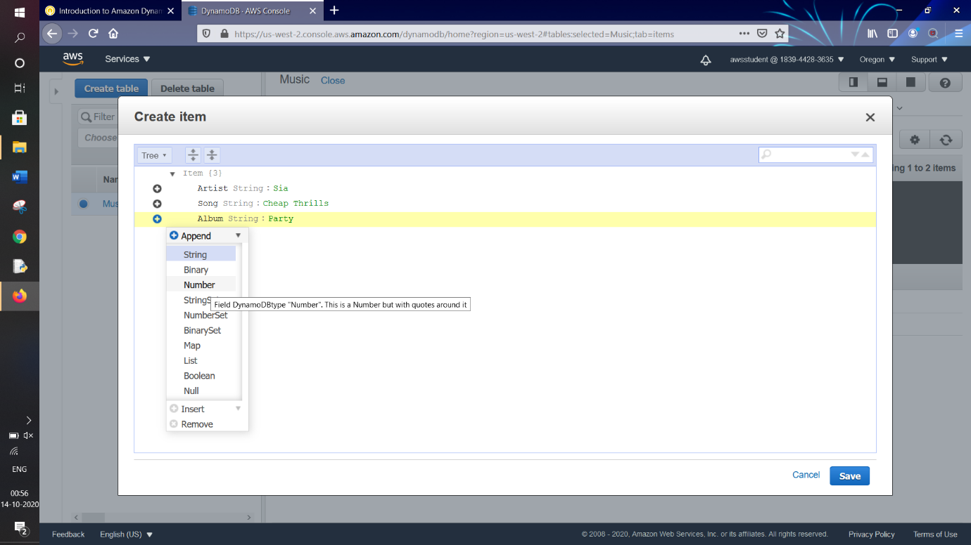

After we click on “**Save**” button



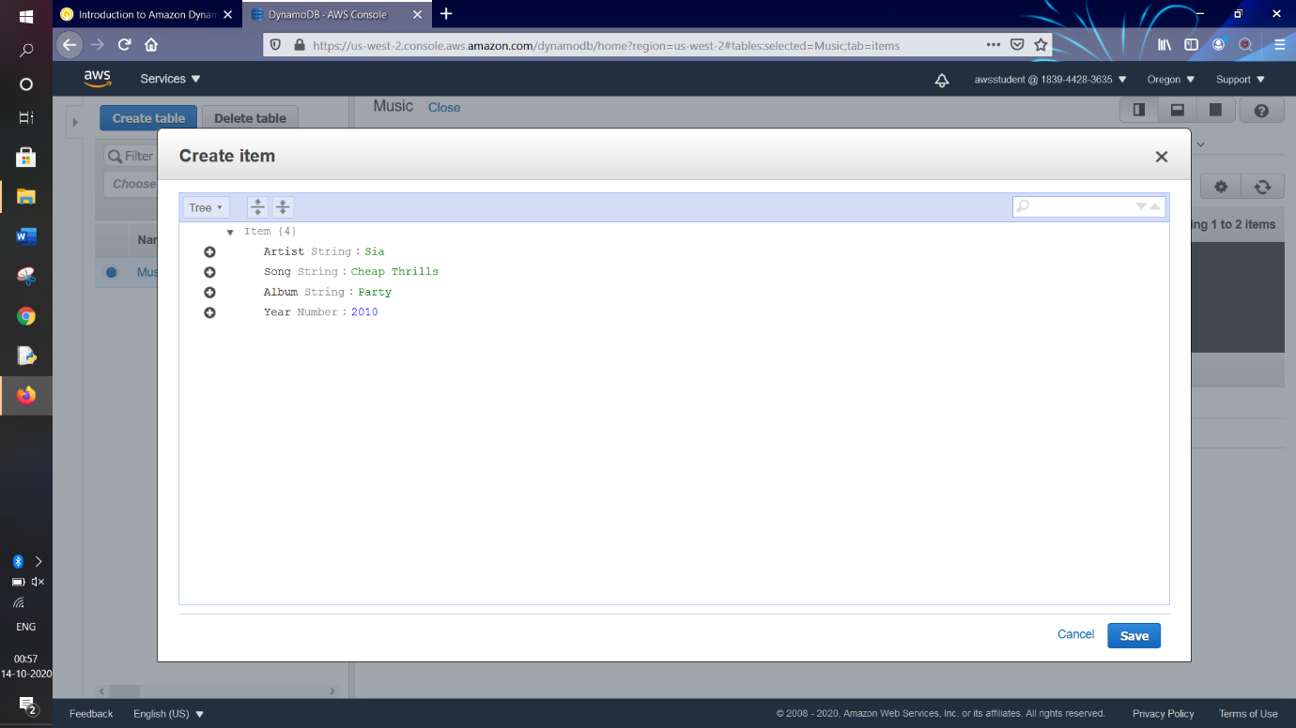

We will see that our all three records are successfully entered into our table

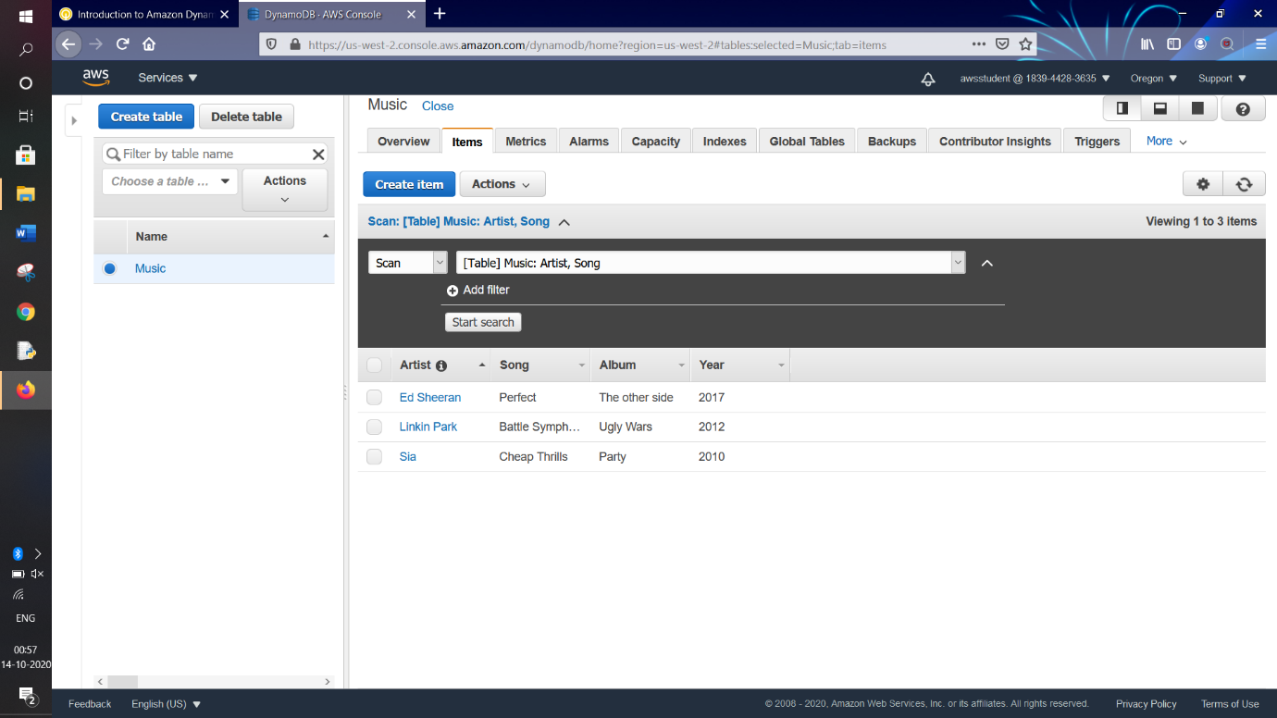

Now we will add additional attributes to pre-saved records and observe the change….

We click on record named with “**Artist**” value as “**Linkin Park**”

The below window appears again,

Add another attribute by clicking  button on left side “**Year**”, then click on “**Append**”

We select “**String**” from dropdown

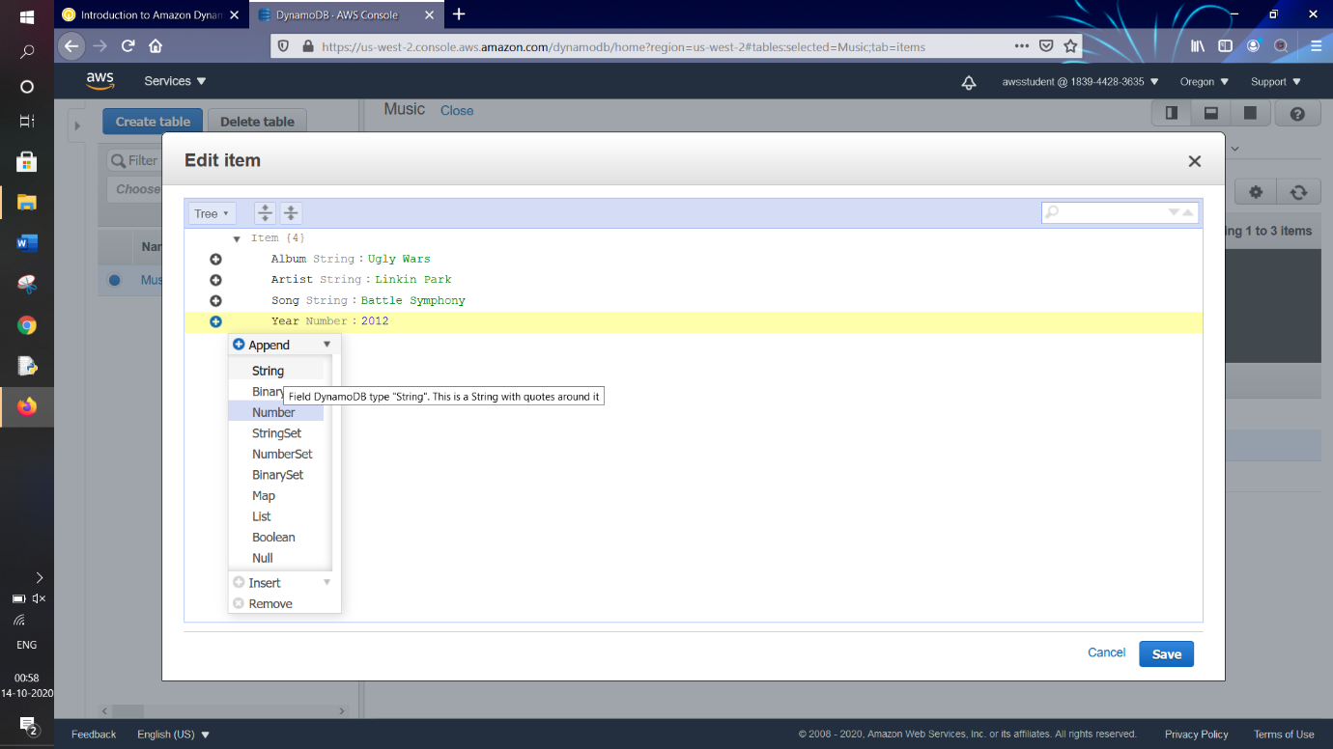

In **Field:** type “**Genre**”

In **Value:** type “**Party Music**”

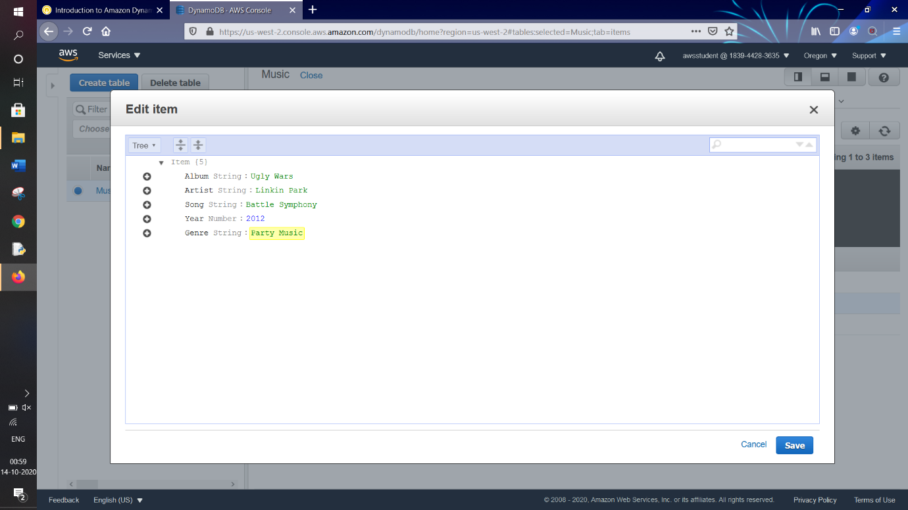

After we click on “**Save**” button



Similarly we select the record having “**Artist**” value as “**Sia**”

Then the below window appears,

Here also we add two more attributes,

Add another attribute by clicking  button on left side “**Year**”, then click on “**Append**”

We select “**String**” from dropdown

In **Field:** type “**Genre**”

In **Value:** type “**Dance**”

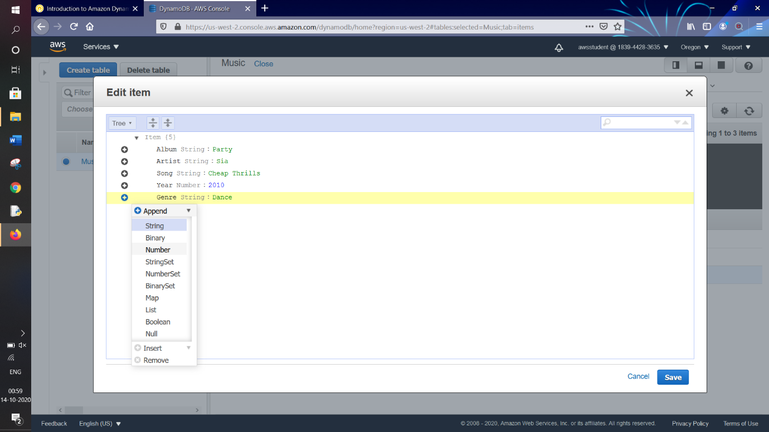

Again Add another attribute by clicking  button on left side “**Genre**”, then click on “**Append**”

We select “**Number**” from dropdown

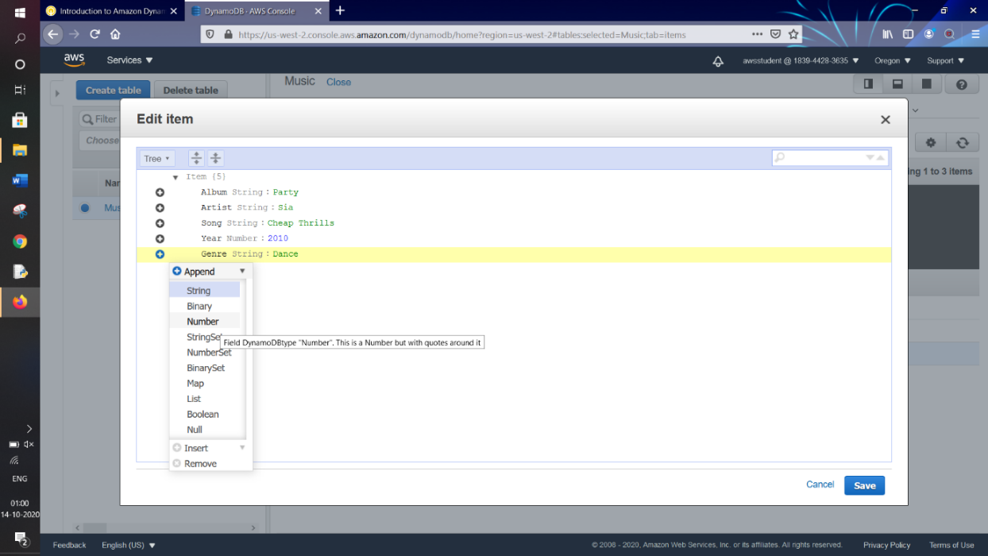

In **Field:** type “**Track Length**”

In **Value:** type “**3**”

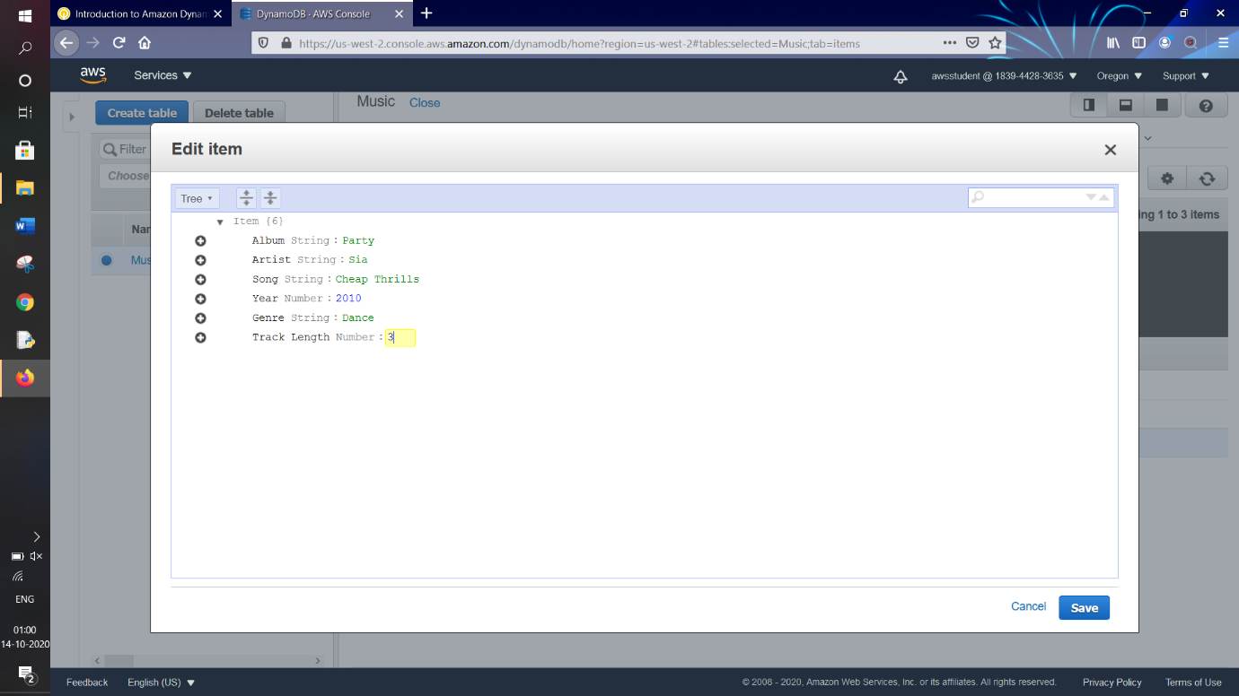

After we click on “**Save**” button



***TASK 3 : Modify Existing Item***

Click on record having “**Artist**” value as “**Linkin Park**”

Change the “**Year**” from “**2012**” to “**2013**”

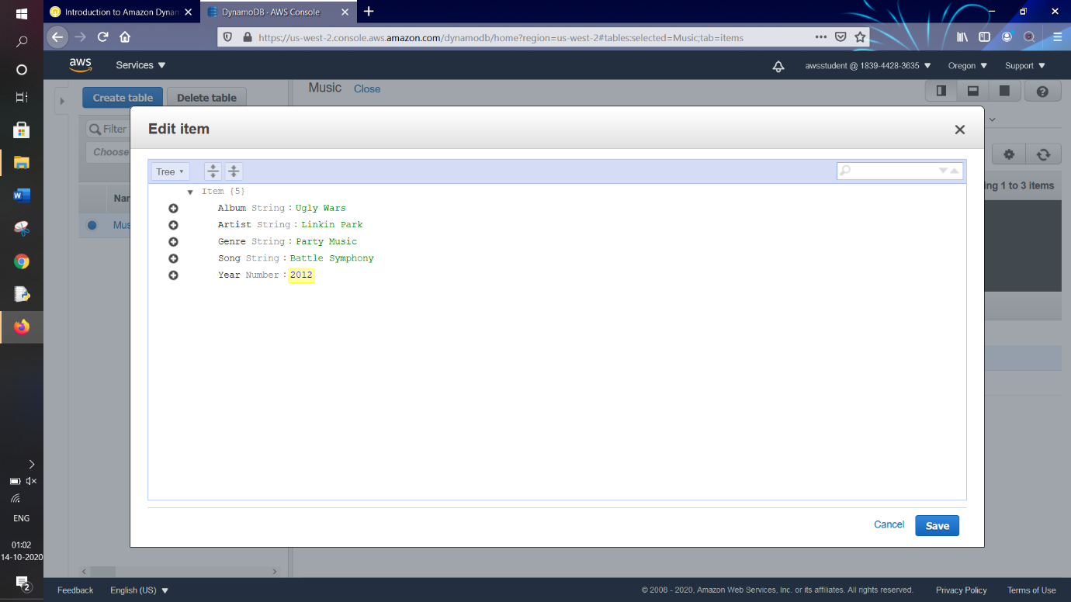

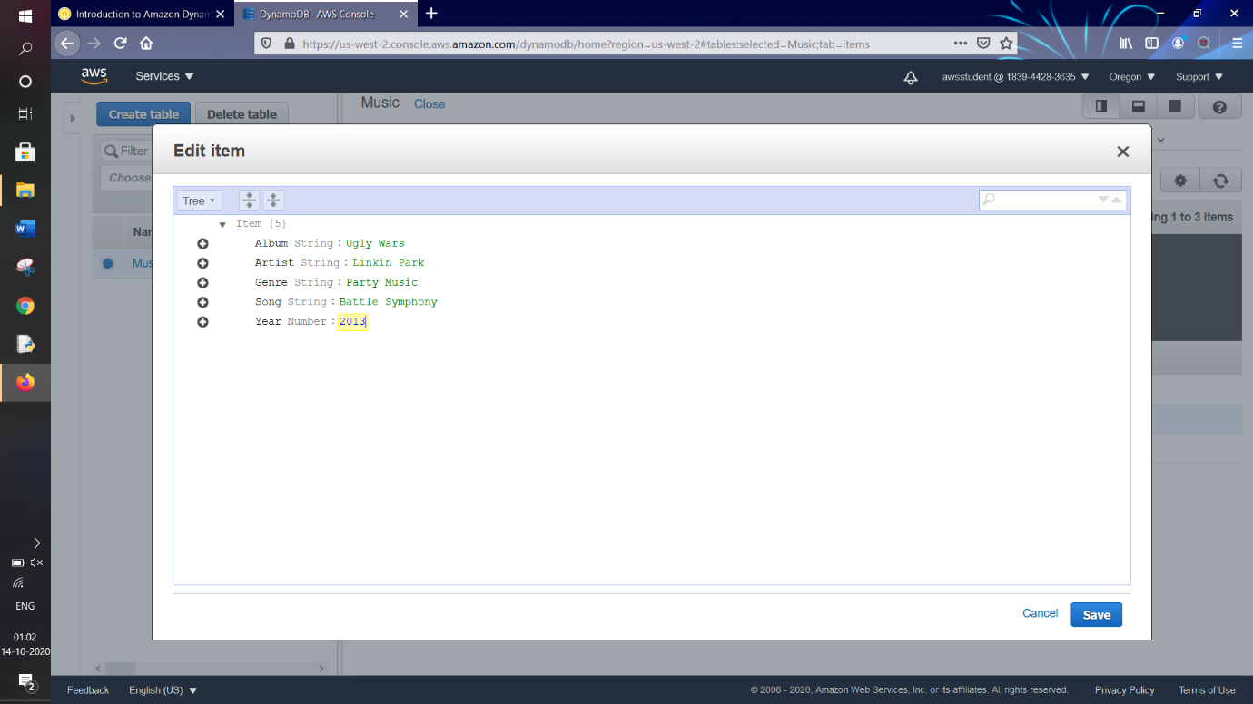

In the below screenshot we can see that table and its all records with their attributes

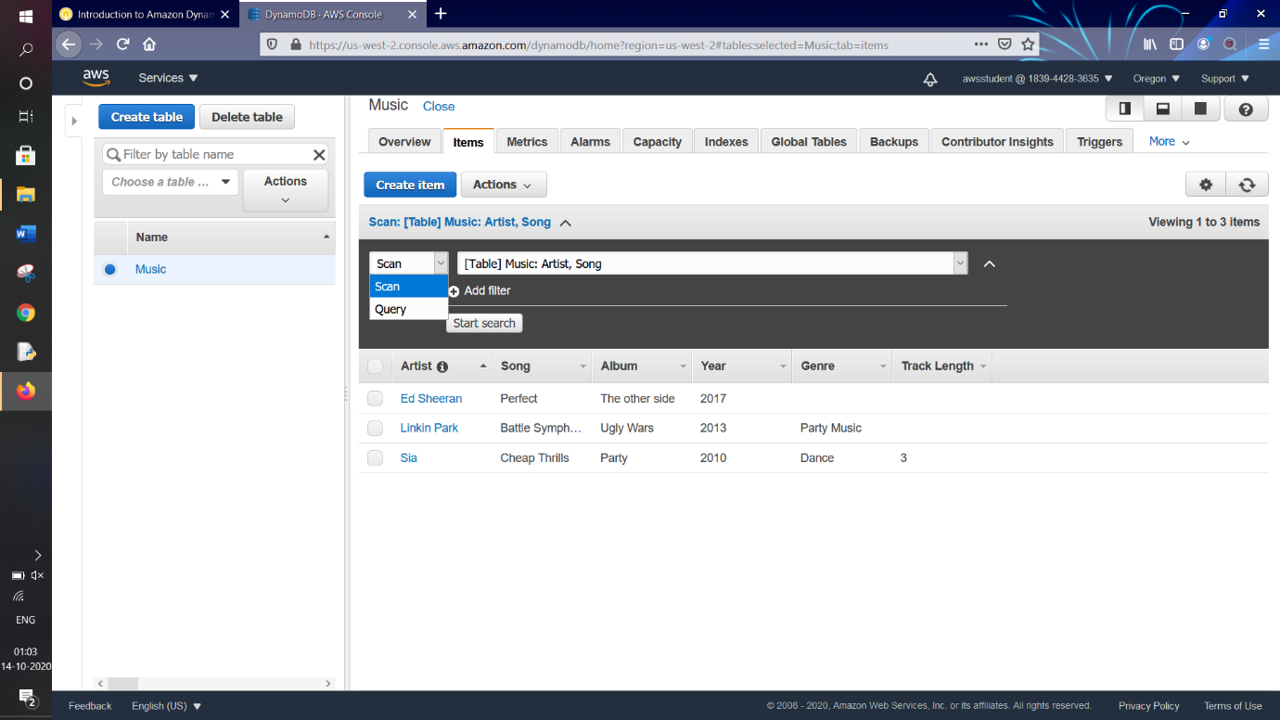

Some records have “**Genre**” attribute while some not or some have “**Track Length**” attribute while some not

This displays the flexibility of NoSQL Database with DynamoDB

***TASK 4 : Query The Table***

There are 2 ways to query the table:

1. A “**Query**” operation finds items based on **primary key** and optionally sorts key. It is fully indexed so it runs fast
2. A “**Scan**” operation which involves searching through each item in table. This is less efficient and can take significant time for larger tables

1. Query Option

Select “**Query**” from the dropdown

Fields for partition key and sort key are displayed now



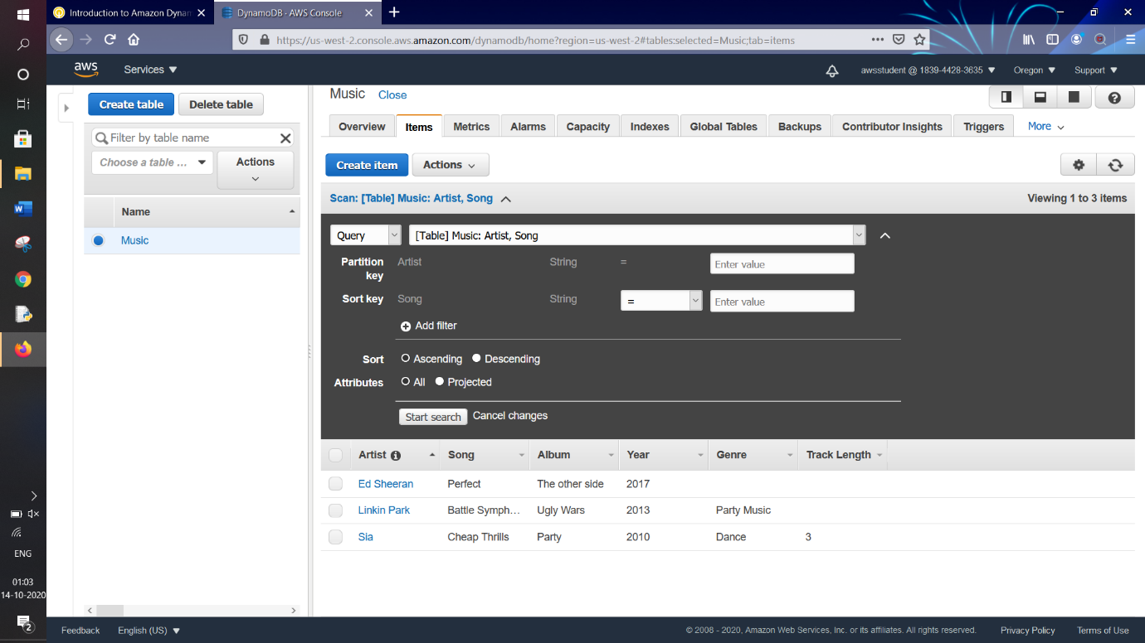

Enter Details as:

Partition Key : type “**Sia**"

Sort Key : type “**Cheap Thrills**”

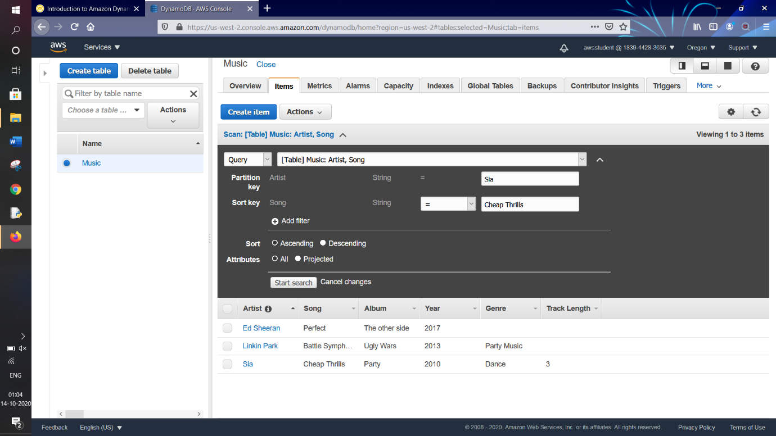

Click on “**Start Search**” 

We see the below result with primary key “**Sia**” as our output

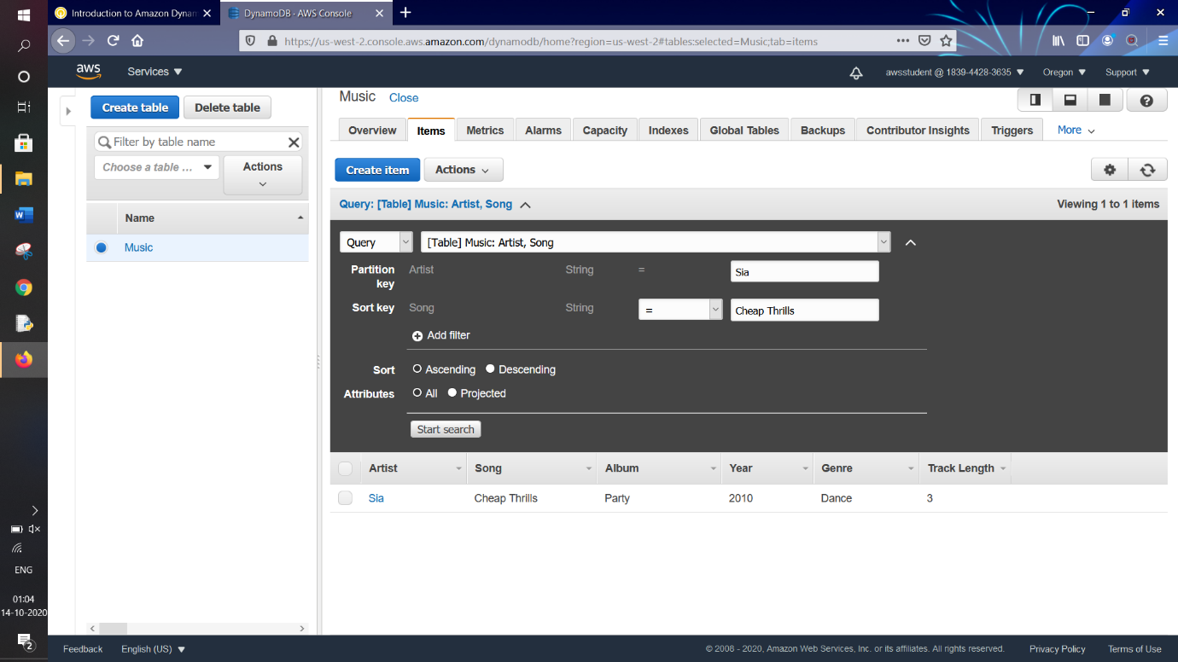

2.Scan Operation

Select “**Query**” from the dropdown

Now click on “**Add Filter**” option by clicking on  button



The extra filter option appears

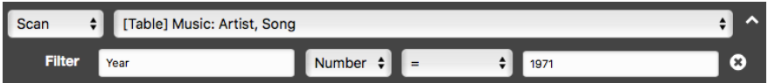

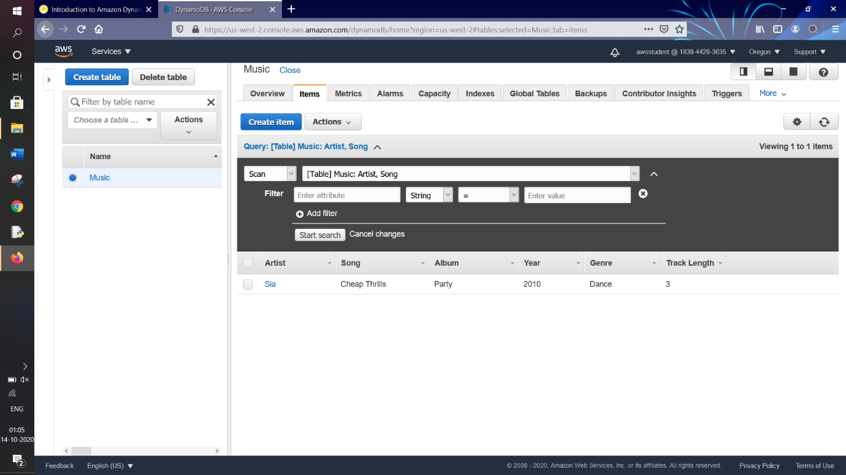

For **Enter attribute**, type “**Year**”

Change **String** to **Number**

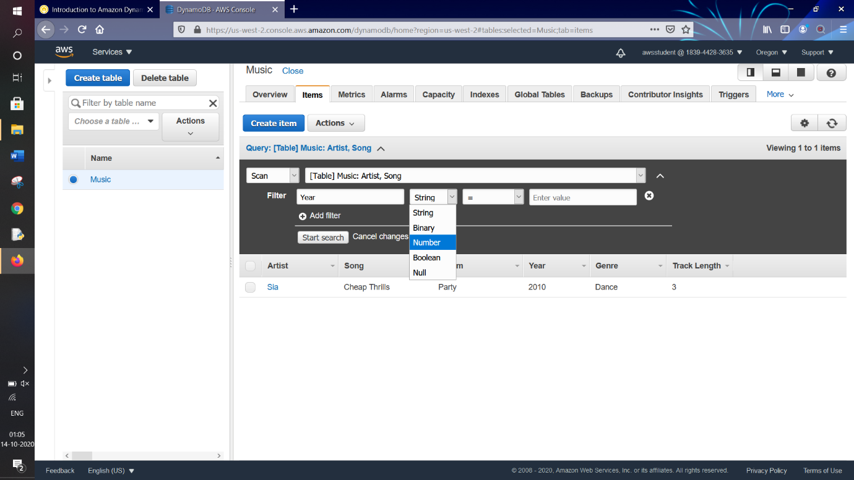

Keep Operator as “**=**”

For **Enter value**, type “**2010**”

Click on “**Start Search**” 

We again get our output of record with value with “**Year**” as **2010**

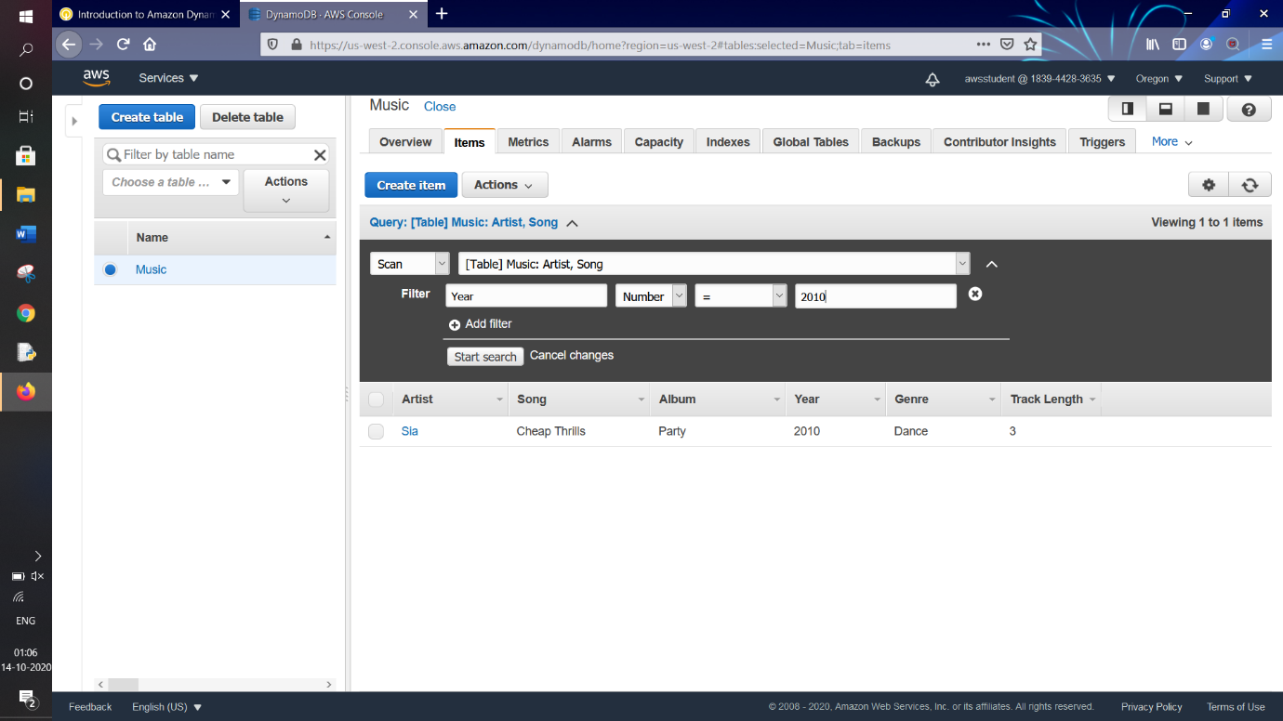

Again For **Enter value**, type “**2013**”

Click on “**Start Search**” 

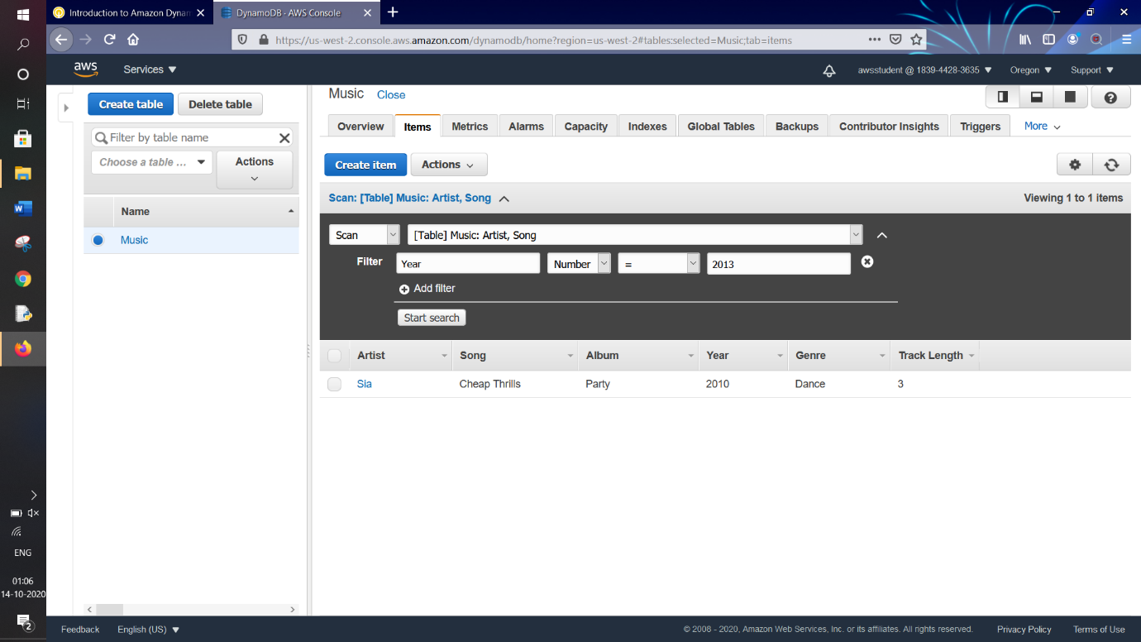

We get our output as record with “**Year**” as “**2013**”

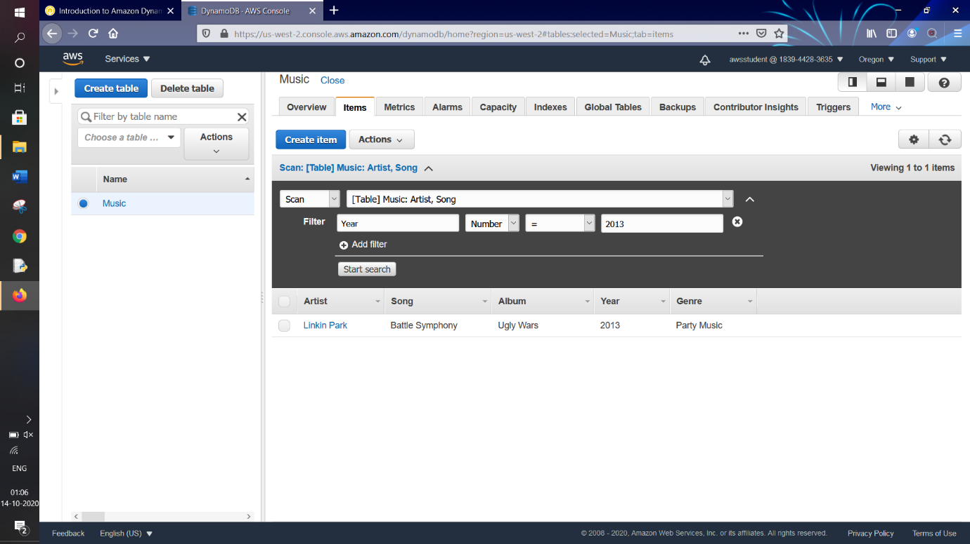

***TASK 5 : Delete Table***

In this task we will delete our table “**Music**” which will delete all the data in it

Click on “**Delete table**” button 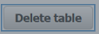

The Confirmation window for “**Delete table**” appears

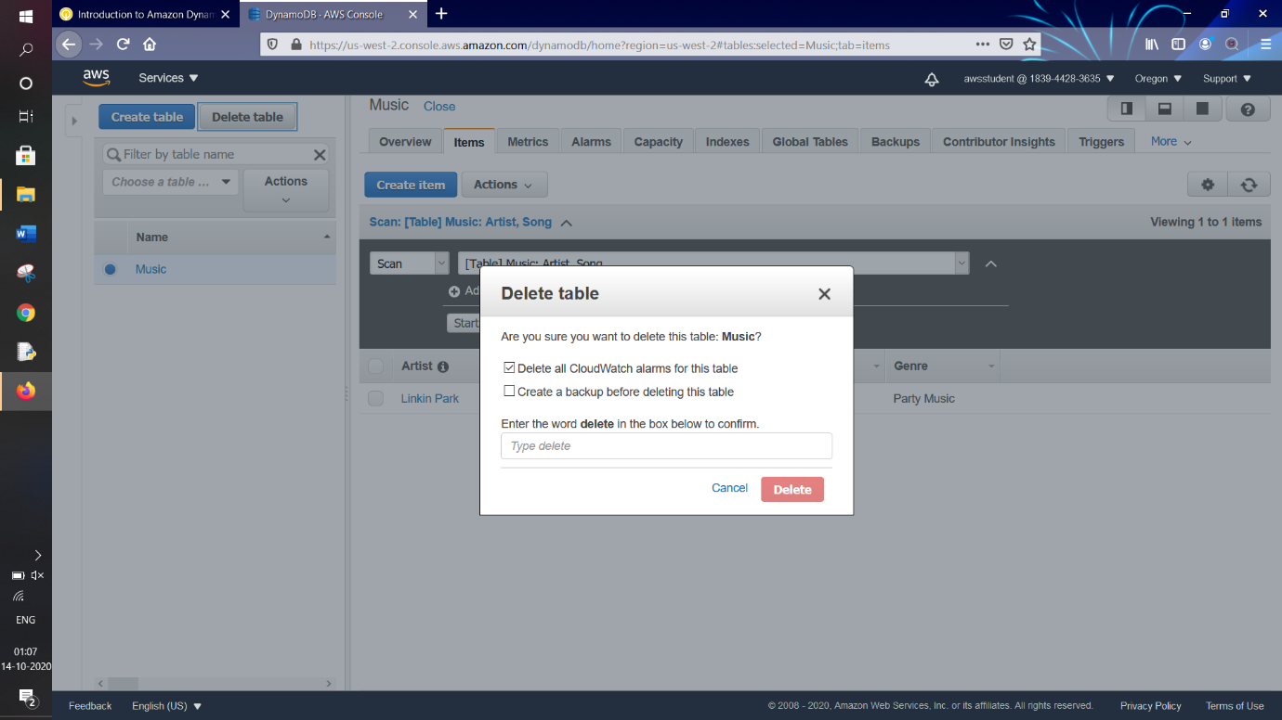

Type “**delete**” in the text field to confirm

Click on “**Delete**” button 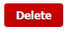

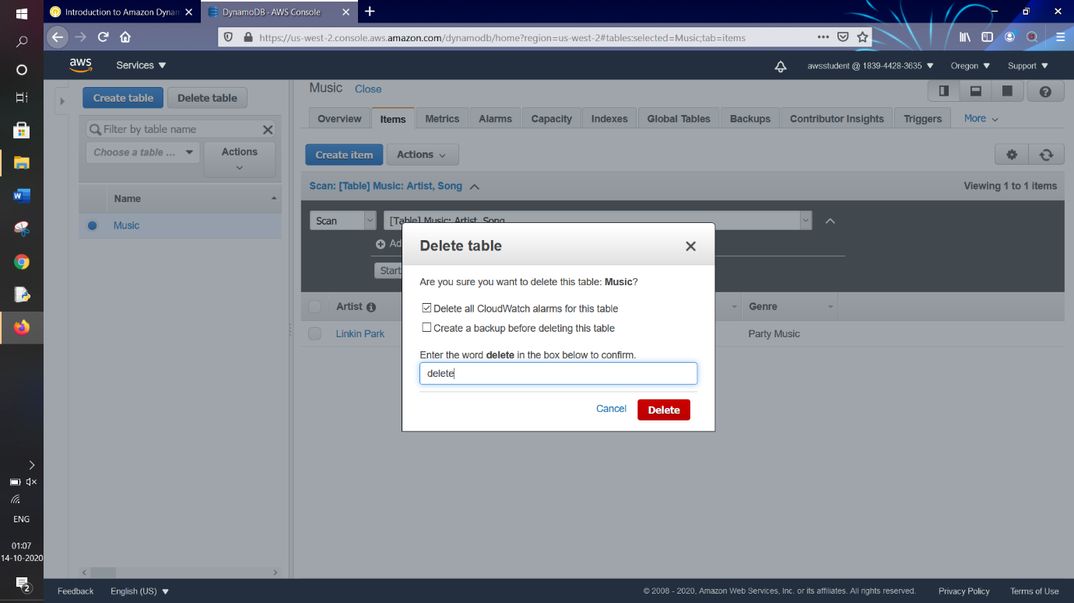

The table gets deleted and we can see that the table has disappeared from the DynamoDB Console

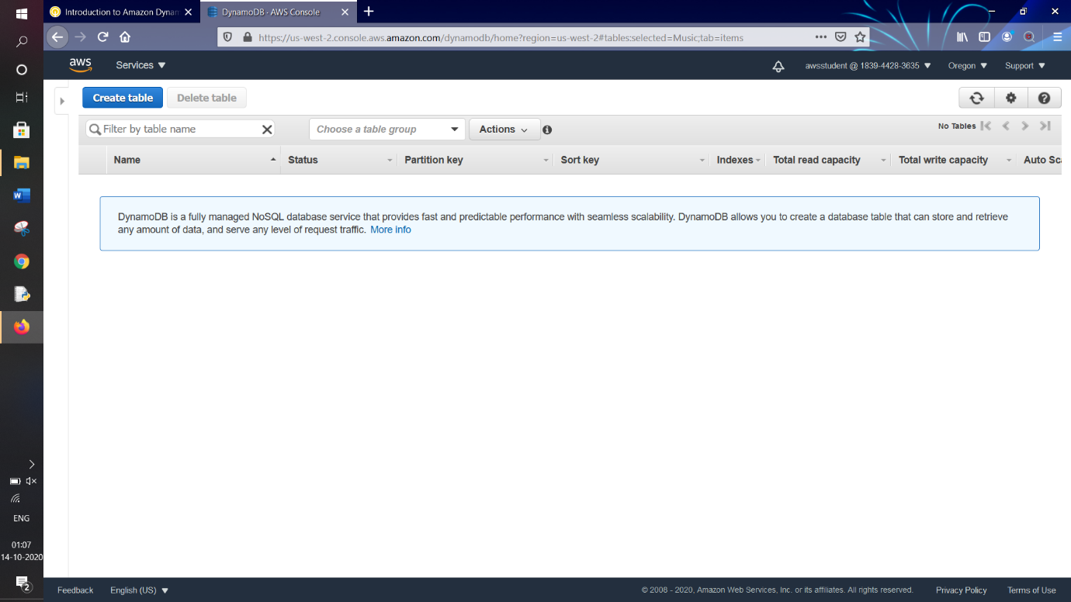

We return to AWS Management Console

Click on our  on navigation bar

Click on “**Sign Out**”

